STRATFUL ASSOCIATES LTD
CHARTERED BUILDING SURVEYORS

New Build Snagging Inspection
  - Customer sample report

This fictional example demonstrates the format and level of detail of our snagging reports. Findings and property details are illustrative. The photographs are AI-generated illustrations and are not evidence from an inspected property.

Property 1 Example Close
Plot number 1
Prepared for Prospective clients
Example inspection date 30 September 2026
Inspection stage Pre-handover

Paul Stratful MRICS
Chartered Building Surveyor
Stratful Associates Ltd
07361 249 464

Report Details
Client name Sample client
Property address 1 Example Close — fictional property
Plot number 1
Inspection stage Pre-handover
Developer Example Homes — fictional developer
Warranty provider NHBC — example entry only
Inspection date 30 September 2026 — example date
Weather conditions Dry and sunny. Ground conditions were dry.
Access restrictions No significant restrictions to the completed rooms. Areas affected by ongoing developer works are described below.
Documents supplied Example entries: warranty information and approved drawings. No completion certificate is assumed for this sample.

Drone Inspection
Example use: a drone assisted inspection of accessible roof coverings. Views of part of the rear roof junction were obscured by scaffolding. The displaced tile is recorded as Snag 1.
The drone inspection is limited to visible external surfaces within the areas viewed. It does not involve physical access to the roof or opening up the construction.

Thermal Imaging
Example use: supplementary checks of selected accessible internal wall and ceiling surfaces. No significant unexplained temperature patterns are assumed in this example.
Thermal imaging records surface temperature patterns. It does not see through construction or by itself confirm missing insulation or moisture penetration. The absence of an unusual pattern does not confirm that construction is free from defects.

Snagging Priority Key

Safety or urgent
Items presenting a potential safety risk or requiring prompt action to prevent further damage. Notify the developer immediately. Appropriate precautions and any necessary temporary measures should be taken until permanent remedial work is completed.

Before occupation or handover
Items that should be resolved before occupation or handover because they affect use of the property or involve significant incomplete work. If handover has already occurred these items should be raised promptly with the developer.

Routine snag
Minor defects in workmanship or finishes that do not require urgent action. Record these with the developer and agree a reasonable timeframe for rectification.
Read each recommended action alongside its priority. Priorities indicate urgency and do not determine warranty coverage.

General Limitations
This report records the condition of the visible and reasonably accessible parts of the property at the time of inspection. The inspection is non-invasive. Fixed finishes and concealed construction are not opened up. Accessible fittings and controls are operated normally where safe and permitted. Services are not specialist-tested or certified as part of this inspection.
Some defects may be concealed or become apparent only after occupation or use. An absence of reported defects does not confirm that an area is free from defects. The report identifies matters to raise with the developer. It does not certify statutory or warranty compliance or confirm that remedial work has been completed.

Restrictions at this inspection
Example restriction: developer works were ongoing. Scaffolding obscured part of the rear roof junction and the unfinished utility room floor could not be assessed as a completed finish. These areas should be checked after completion and removal of the obstruction.

Snag Table
Illustrative findings • Refer to the priority key and inspection limitations.
Snag No. | Location | Element | Defect | Action | Priority
1 | Front roof slope | Roof | One tile is displaced and leaves a gap in the covering. Photo 1. | Refix or replace the tile. Check adjacent fixings and underlying weather protection. | Before occupation or handover
2 | Dining room | Floor finish | The surface of one laminate plank is visibly scratched. Photo 2. | Repair to an acceptable matching finish or replace the affected plank. | Routine snag
3 | Kitchen | Kitchen units | Adjacent base cabinet doors are misaligned with uneven gaps. Photo 3. | Adjust hinges and align the doors. Confirm that they open and close freely. | Routine snag
4 | Shower room | Sealant | A section of sealant is missing at the shower tray and wall junction. Photo 4. | Complete the seal with a suitable compatible sanitary sealant before shower use. | Before occupation or handover

Snag Table Continued
Illustrative findings • Refer to the priority key and inspection limitations.
Snag No. | Location | Element | Defect | Action | Priority
5 | First floor landing | Balustrade | A balustrade fixing is loose and the guarding moves under light hand pressure. | Notify the developer immediately. Restrict access to the affected edge until the guarding is securely fixed and checked. | Safety or urgent
6 | Entrance hall | Ceiling finish | A fine local crack is visible in the ceiling finish near the wall junction. | Repair the cracked finish and redecorate the affected area to match. | Routine snag
7 | Bedroom 2 | Internal door | The door catches the frame and does not latch during normal operation. | Adjust the door and ironmongery. Confirm free operation and secure latching. | Before occupation or handover
8 | Bedroom 1 | Window | Protective film and adhesive residue remain on the accessible frame. | Remove film and residue using an appropriate method without damaging the finish. | Routine snag

Snag Table Continued
Illustrative findings • Refer to the priority key and inspection limitations.
Snag No. | Location | Element | Defect | Action | Priority
9 | Rear elevation | Rainwater pipe | The lower downpipe connection is incomplete and water can discharge beside the wall. | Complete the connection to the intended drainage point and check flow and joints. | Before occupation or handover
10 | Living room | Skirting | The mitred skirting joint beside the doorway is open and the decoration is unfinished. | Make good the joint and complete preparation and decoration to match. | Routine snag
11 | Bathroom | Basin waste | Water drips from the accessible waste joint when the basin is emptied. | Repair the waste joint and retest. Check and dry any affected surfaces. | Before occupation or handover
12 | Front path | Paving | One paving slab rocks underfoot and creates an unstable walking surface. | Make the area safe promptly. Lift and rebed the slab on a suitable stable base. | Safety or urgent

Photo Appendix
AI-generated illustrations for this fictional sample. These are not inspection photographs.
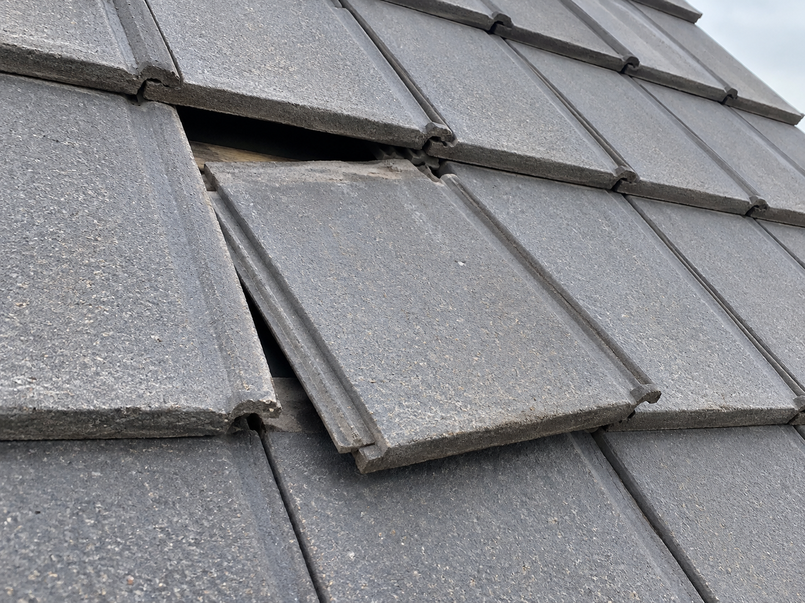
Photo 1 • Snag 1 • Displaced roof tile
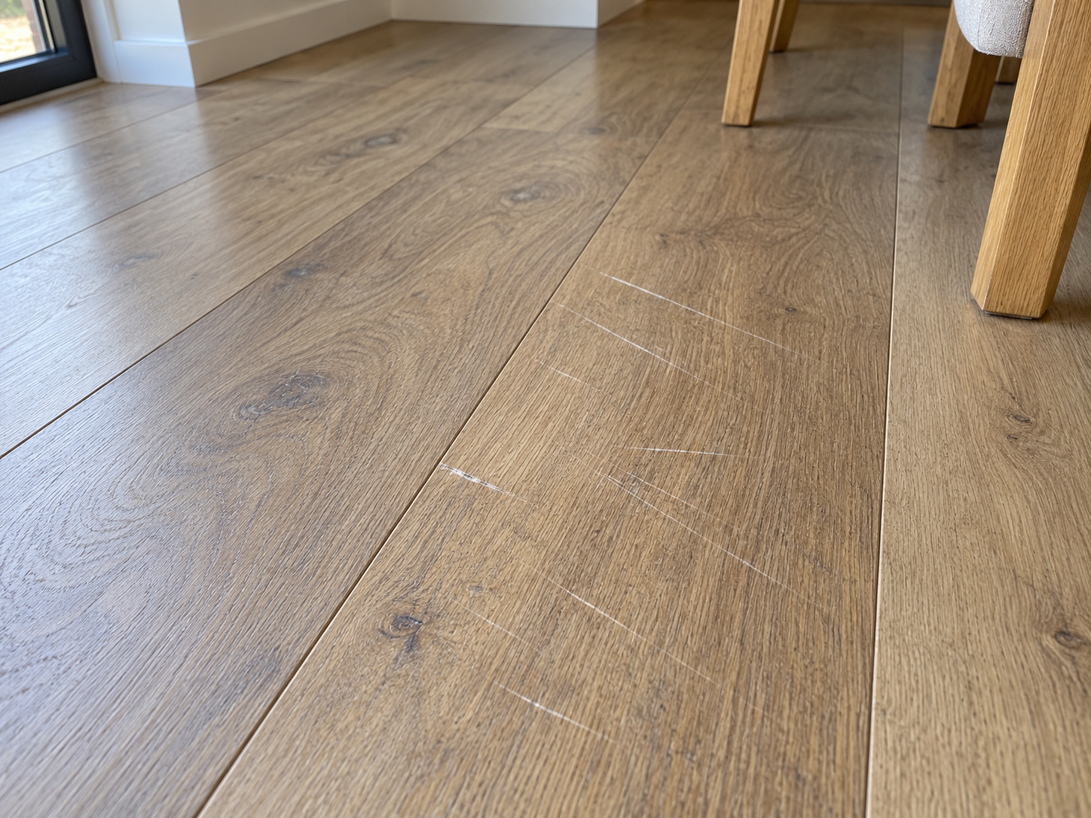
Photo 2 • Snag 2 • Scratched floor finish

Photo Appendix Continued
AI-generated illustrations for this fictional sample. These are not inspection photographs.
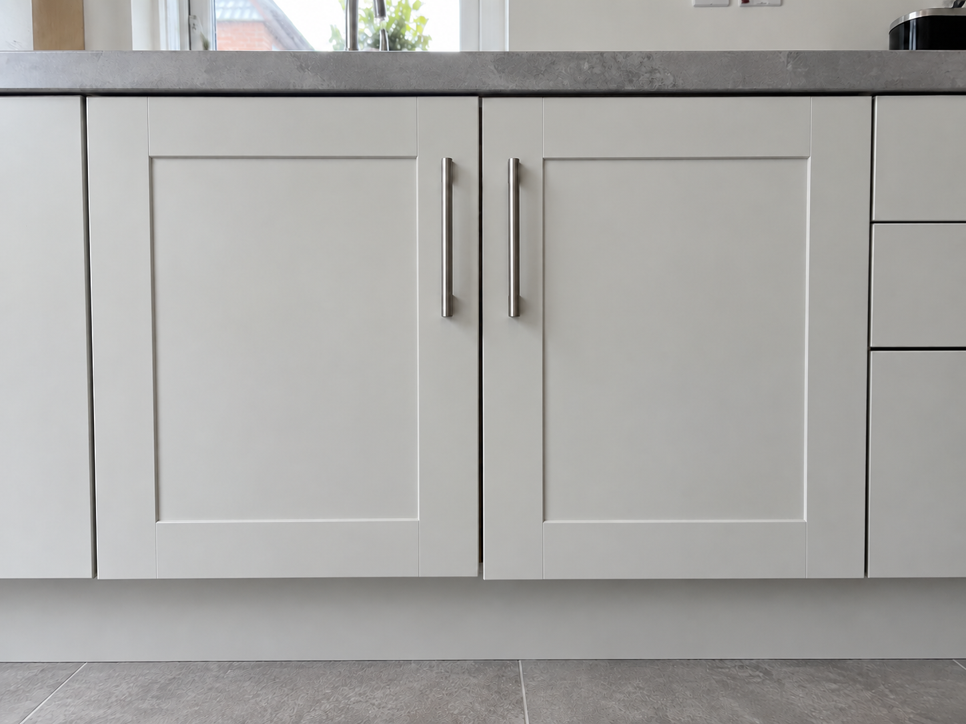
Photo 3 • Snag 3 • Misaligned cabinet doors
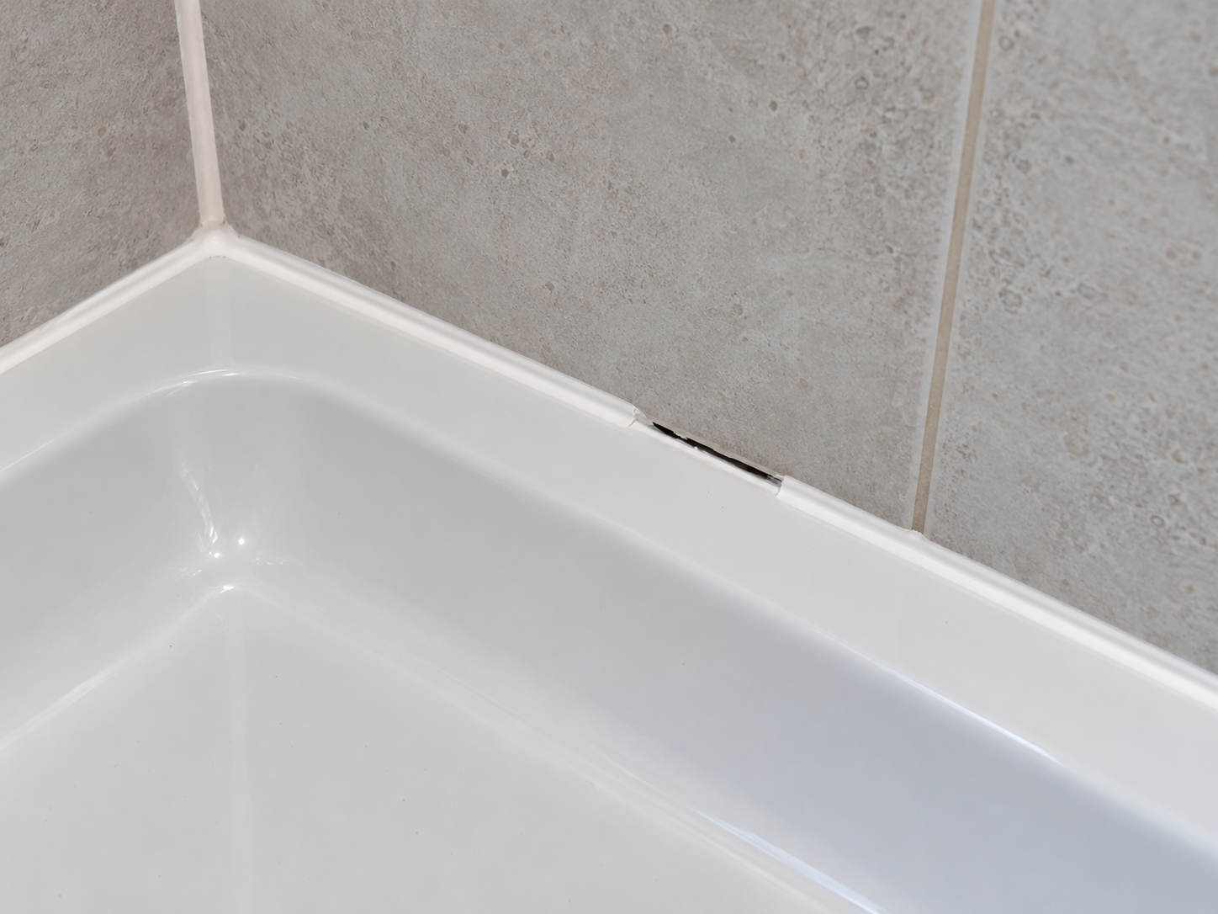
Photo 4 • Snag 4 • Incomplete shower tray sealant

